Lesson plan
Unit 13 | Lesson: 38 | At the market

Date
Class:
Date
Class: ‏
Objectives:

By the end of this lesson pupils should be able to:
- Asking about preferences / ordering fruit and vegetables
- Enquiring about prices
New language:
Vocabulary : chicken – fish – butter – cheese – bread – orange – apple – pear – basket – shop

Structures: can I help you ? I’d like / How much (price)
Pronunciation: Vowels in minimal pairs
Teaching aids :
A tape recorder / pictures
Stage | Procedures | Time
Warming – up |   Teacher asks different pupils to say the last song (Where is the zoo?)  Teacher asks pupils to take their slates and invites them to write some words : I like football – swimming – running the bank is between the park and the supermarket (dictation) | 10mn

Presentation | Teacher presents a picture of a market then she asks: Do you know this place? name it …  Pupils try then teacher introduces: The supermarket.  Teacher asks: What do you find in the market?  Pupils try then teacher introduces :  In the market there is fruits and vegetables  Then she asks: What’s this?  Pupils try; then teacher introduces the name of the fruits and vegetables presented  orange – apple – pear – carrots – potatoes – tomatoes – bananas – cucumber - pepper – strawberries  Teacher asks: What do you find other in the market?  Pupils try then teacher introduces : meat – chicken – fish – cheese – butter – bread – milk …  Teacher presents a picture of fruits and vegetables  Pupils use new words in sentences using some pictures presented on the black board.  Teacher asks pupils about their town and makes them making a sentence using the new words. | 25mn
Practice | 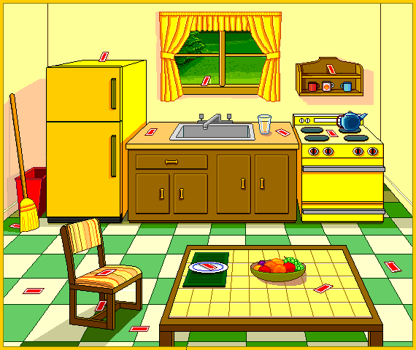  Teacher invites pupils to open their books at page189  Teacher reads .  Pupils follow on their books.  Then pupils read the text to.  Then pair practice: a dialogue between the grosser and the client in the market .  Pupils read and point (page 191)  Teacher asks pupils to read then do the activities on page 192/193  Then check and correct   | 25mn

